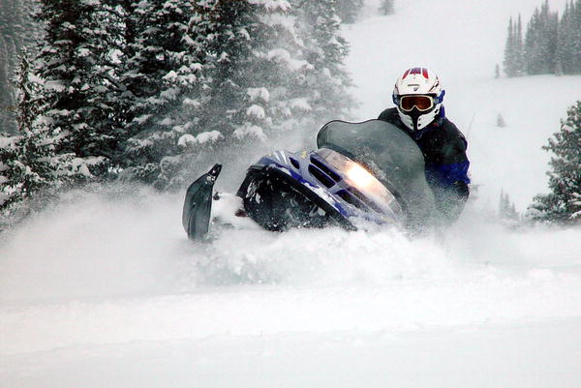
Thursday, October 25, 2007

Stranded in the Snow for Eight Days
By: Charles Horton

As Told to Joe Spring
THE SNOWMOBILES PASSED me twice. I was only five feet off the road, but I was in a tree well, where I'd taken shelter under a blanket of branches. Snow from a blizzard the night before camouflaged my tracks.
I had been stranded for eight days. My core temperature had fallen to 88 degrees, I was dehydrated, and I'd lost 35 pounds. No strength to yell.
I had gone cross-country skiing near Steamboat Springs, Colorado, and was going downhill in a meadow. I wasn't moving fast, but I was moving quickly enough to make turning tricky, especially in snow that was rotting under the April sun.
My right ski punched through the crust and locked. There was no audible sound. It just felt like hitting your funny bone. But I pulled up my pant leg and saw the lower bones in my right shin twisted beneath the skin.
I grabbed an herb called arnica that I always carry in my pack to prevent shock, then I took a moment to think. It was Sunday. I had told my neighbor where I would be skiing but not when to expect me back. I had matches, a magnesium bar, a lighter, a whistle, some nuts and dried fruit, two energy bars and some chocolate, a half-full CamelBak, two knives, a hat, four layers of wool clothing and a non-waterproof shell with a hood.
I put on all my clothes, then wrapped a knee pad around my broken shin and used my backpack as a splint. I wanted to get off the snow and there was dry ground back in the meadow, but there would be a better chance of snow-mobile traffic along the road.
From a sitting position, I worked out a crawl using my left leg and right elbow, and about 20 minutes after the fall, I started to move. Two hours and 500 feet later, I saw a deep tree well just off the road. It would soon be dark, and I need shelter. I crawled in and spread some branches on the ground. I drank all my water, and then built a fire, which lasted through most of the night. I got cold, but surviving that first night me confidence.
Then the pain came. My leg muscles cramped and the bones ground together whenever I moved. I tried to build another fire, but I was out of matches, and the plastic lighter melted when I held it down too long trying to light wet leaves. I still had the magnesium bar, but the shavings scattered because I was shivering so badly. I discarded what I had heard about not eating snow, because I needed water. My neighbor was supposed to go out of town on Tuesday. So by Wednesday I realized she hadn't reported me missing.
Over the next few days, I inch-wormed more than half a mile. One day I crawled for 13 hours, convincing myself not to give up by thinking of the anguish others would feel if I died. I spent the nights in tree wells, but the shivering made it hard to fall asleep.
My neighbor came home Sunday night and called search and rescue.
When I heard the engines stop the next morning, I blew my whistle three times. I saw someone and waved from beneath the tree. He said, "Are you Charles Horton?" I said, "If I'm not, are you gonna leave me here?"
Expert Analysis: Never go out alone without telling someone where you're going and when you'll be back.
As for supplies, the whistle was key.
In those temperatures, it would have been pretty easy for him to use the sun and the supplies he had to melt snow for water. Everyone should learn how to do that. —Sherly Olson, medevac nurse

Thursday, October 25, 2007 2

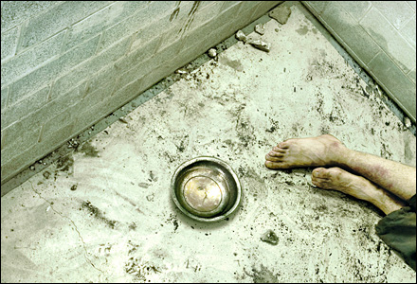
Held Captive in a Serbian Jail
By: Bill Carter

Photo: Photo by Joe Baran

WE JUST WANTED to have a party.
It was May 1993, and the Bosnian war was in full swing. I had been in the region for about five months working for a humanitarian-aid group called the Serious Road Trip. We transported food, medicine, and clothing from the Croatian port of Split to Sarajevo, which was under siege by nationalist Serbs and was probably the most dangerous city in the world. We dressed up as clowns and drove trucks painted with cartoon characters like Bart Simpson and Wile E. Coyote. The costumes made kids smile and helped us get through military checkpoints. At least, most of the time.
A Bosnian friend's band was going to play at an underground club, so my co-worker Graeme and I offered to buy vodka, which meant driving about 20 miles north of the city. Around noon, we rolled our old Land Rover—painted like a Rastafarian flag, with smiley faces on the hubcaps—up to the checkpoint on the only road out of the city. The haggard Serb soldiers waved us through.
When we returned, six hours later, they searched the Rastamobile and quickly found our 12 bottles of cheap Russian vodka under a pile of clothes in the back. They ushered us to a small concrete building and into a bare, rank room with a single window. Before shutting the steel door, an unkempt, bearded guard told us we would be sentenced in the morning for smuggling.
In Bosnia in the early nineties, every day felt like the day before you were going to get executed. But this time it was for real. A number of journalists and aid workers had been murdered in recent months, and now it was our turn. All for a booze run.
Within an hour, two guards barged into our room reeking of plum brandy. They pointed their Kalashnikovs in our faces, screaming, "You're going to die!" We cowered on our hands and knees, begging them not to shoot. They pulled the triggers. Click. No bullets. They laughed hysterically. Every hour or so they'd do it again.
Around midnight, mortar rounds shook the building. The Bosnian army in Sarajevo was fighting back. The guards were in our room when it started and loaded their guns. Now they were wide-eyed and sweating, just like us, and shouting with true anger: "Clinton is the devil!" "America is pigs!" Graeme and I tucked into a corner. The light bulb went out and chunks of the ceiling rained down.
Finally, after a long period of silence, one of the guards exhaled loudly. Then, without really thinking, I did what may have saved our lives: I offered him a cigarette. I don't smoke, never have. I used cigarettes as a way to break the ice, though up until that moment only with "friendlies." The guard accepted, and as he smoked I brought up basketball, figuring he would like the L.A. Lakers, since their center, Vlade Divac, was a Serb. I said I was a Chicago Bulls fan, even though I wasn't. We all had a broken bilingual debate until dawn.
A few hours later, the guards released us. Machine guns crackled in the distance. One of the men gave us the keys to the Land Rover and, without saying a word, motioned for us to leave.
We drove back into the city, now being bombed by the people we'd just left. Graeme rifled behind the seats. "So much for the vodka!" he yelled.
Expert Analysis: While it's a good idea to clearly identify yourself as a noncombatant, the downside is that you are highly visible to anyone wishing to take a shot at you. And, in this case, not everyone will see the humor, especially if they're drunk. Cigarettes or other such commodities are as important as cash in these environments. And anything that isn't a delicate subject (like politics or religion) can be used to calm tense situations and open up conversations—it's always difficult to hurt or kill someone you know and have something in common with. —Tim Crockett, former Royal Marines commando and executive director of AKE Group, which trains civilians who work in hostile environments

Thursday, October 25, 2007

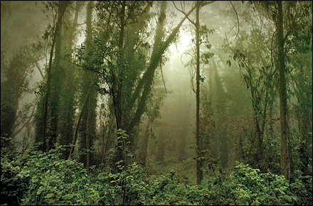
Starving in the Amazon for Seven Weeks
By: Guilhem Nayral

Photo: Photo by Joe Baran

As Told to Andrew Taber
THE THOUGHT OF BEING categorized as a missing person was hard to accept. When there's no body to be found, the grieving has no end. For our families back in France, we had to survive.
I was lost in the Amazon with my friend Loïc Pillois. We had gone there last February to hike an approximately 78-mile section of virgin forest that was supposed to take us from our drop point on the Approuague River to Saül, an isolated former mining town at the geographical center of French Guiana.
We brought along enough food for the 11 days we had budgeted for the trek, along with a compass, a machete, a 60-square-foot tarp, and two hammocks.
Some days went smoothly, and we seemed to be on track. But on other days it would take several hours of hacking through vines to hike just one mile. On the morning of the 12th day, February 26, we knew we were in trouble. Saül sits in a small valley, but the route ahead of us kept rising. We were exhausted and out of food, and we had no idea where we were on our trajectory. Two days from Saül? Two weeks?
We knew there would be a search, so we decided to stay put. We used the tarp to create a roof, and we divided the tasks. I was in charge of food. Loïc tended the fire. We had only one lighter, so Loïc never let the fire go out. He was incredible.
When it's a necessity, it's easy to tap into the survival instinct. We became very primal. It was the rainy season, so we had water. But we started eating whatever we could. If we thought a plant was edible, one of us would try it. If he was still OK the next day, we knew we could eat it. We ate beetles, and we trapped mygale spiders [tarantulas]. They're huge and hairy. If you cook them well enough, their venom burns off and they become edible.
Still, we were starving. We chewed just to chew. Psychologically, it helped. We even ate bugs that swarmed to our excrement.
Occasionally, we'd hear helicopters. But we couldn't see them, and they couldn't see us or our fire through the thick canopy. Sometimes days would go by with nothing. That was sheer panic. Had the search been called off?
We learned later that the rescue missions did stop, on March 26, 40 days after we'd started our trek.
Around that same time, we decided that we weren't going to be found and abandoned our camp. We calculated which way was west, toward Saül, and left. A week later, we caught a turtle, probably seven pounds. It was our first meat in five weeks, and we ate absolutely everything—skin, claws, scales. We heated the blood over the fire and drank it. Honestly, it tasted amazing.
The next day, I caught another spider. I cooked it, but not enough; the venom was still active. I spit it out, but pain engulfed the entire left side of my tongue. It swelled up and my lips went numb. It was excruciating. I tried to keep going, but I was too weak. I was suffering from intestinal poisoning and couldn't go on. By this point, Loïc had lost 35 pounds and I had lost 57. One time I sat on the ground and felt a small stone jabbing me. I reached around to clear it and realized that what I felt was my own coccyx.
Loïc left me to make a final dive into the jungle in search of help. A day and a half later, on Thursday, April 5, a helicopter came and hovered above the treetops. Loïc had made it. A gendarme rappelled the 150 feet to the ground. He was crying when he took me in his arms. Of course, so was I. After 51 days in the jungle, it was finally over.
They told me I was just two and a half miles from Saül. I couldn't believe it. I had walked 75 miles only to fall in the final three. I was furious—but not at the forest. I was the one who ate that spider. I was responsible for what happened. I'll go back someday. I'll go back with my girlfriend, Emilie, who flew to French Guiana as soon as she heard I was missing. We'll find that last camp and we'll walk those last two and a half miles together.
Expert Analysis: Their desire to survive got them through, but where were the local guides? If you go into the jungle, a guide, or at least a lot of knowledge from local sources, is invaluable. Anyone with jungle time will tell you six miles a day in virgin forest is the best you can hope for. To plan for nearly seven miles a day, with no room for error, suggests a lack of experience.
One lighter between them and no communications kit? An Iridium 9505A sat phone [from $1,000; iridium.com] can be tracked online, and you can get a signal even in the jungle. We also use flares, floating fires that we tie off in the center of a creek or river so the smoke can break the canopy, and tethered location-marker balloons. The balloons weigh about four pounds and have a chemical that inflates when mixed with water. They float up to mark your location.
Not sure about the spiders; ask a venom man. [Ed's note: We did. According to Norman Platnick, of the American Museum of Natural History, it was most likely the spider's barbed urticating hairs, not the venom, that caused Guilhem's violent reaction.] Regardless, there are plenty of other things that are easy to catch, like tortoises, snails, and fish—you should always have a fishing kit in the jungle. —Ian Craddock, cofounder of Bushmasters

Thursday, October 25, 2007 4

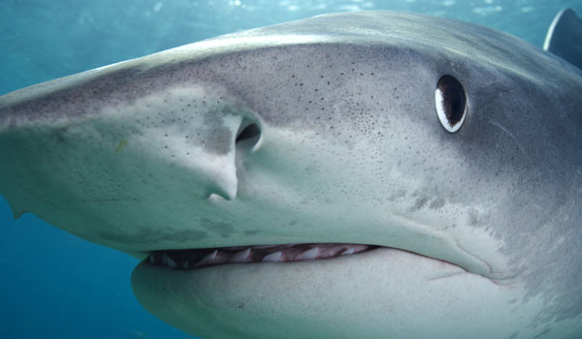
Attacked by a Tiger Shark
By: Hoku Aki

Photo: Photo by Joe Baran

As Told to Ryan Krogh
I WAS 17, AND IT WAS the first day of spring break. I was lying on my bodyboard at Kauai's Brennecke Beach, feet dangling in the water, waiting for another set of waves, when something bit my leg and pulled me under, ten feet to the bottom. When I realized it was a shark—people watching from the beach later told me it was a 13-foot-long tiger shark—I started punching it in the nose. But it didn't care and began thrashing me around like a mad dog with a stuffed animal. It let go for a second but grabbed a hold of me again and took me down feet-first, while I kept punching it as hard as I could.
When I saw its gills, I reached in and started ripping everything out. But it didn't faze the shark. It just got stronger and angrier. Every time I'd do something, it just thrashed me more. Then I saw its eye. I reached in and just ripped it out. I saw blood coming out of the socket. It was surprisingly easy, and the shark kind of tweaked out for a second. Then it let me go. I dropped the eyeball and swam to the surface. I was under the water for more than a minute. I should have been struggling for air, but it felt like I was breathing underwater.
Luckily my board was still attached to my wrist. I climbed on top and started yelling for help, paddling to shore. I managed to catch a wave and get close enough so that people could pull me onto the sand. There was blood all over the beach and in the water. I knew it was mine, but I only felt as if the wind had been knocked out of me. A nurse named Nancy saved my life by wrapping my leg in towels and stanching the flow of blood until the ambulance arrived. By the time it showed up, my brother was there. I asked him if I was OK and he told me my foot was gone. The shark bit me right below the knee, and the only thing left was the bone. The doctors told me later that I'd lost 70 percent of my blood.
I have a prosthesis now. But two surgeries and a month and a half later, I was bodyboarding again.
Expert Analysis: Hoku did everything correctly. Tiger sharks are difficult to fight off once an attack is under way. Hitting a shark on the tip of the snout is a good idea, but this is effective only prior to an actual bite. Afterwards, clawing at the gills and eyes is the best possible strategy. By this time, the shark is fully into its attack behavioral sequence, and only the weakest, most sensitive areas are vulnerable. Always demonstrate strength—there's no such thing as playing dead around a shark! —George Burgess, director of the Florida Program for Shark Research and curator of the International Shark Attack File
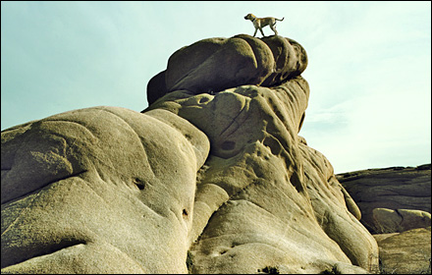
Thursday, October 25, 2007

Bleeding to Death in the Desert
By: Danelle Ballengee

Photo: Photo by Joe Baran

As Told to Devon O'Neil
WHEN I LEFT MY HOUSE in Moab last December, I was just going out for an easy two-hour run with my dog, Taz. I'd finished an adventure race a couple weeks before and was transitioning to the winter season: snowshoe racing and winter triathlon.
About an hour in, I was scrambling out of a remote canyon to connect one trail to another. It was cold, and there had been a frost. The ground was ice. My foot slipped out from under me, and I started sliding down a smooth rock face on my back, picking up speed like on a waterslide. The next thing I knew, I went over a 20-foot ledge and smashed into the canyon floor. I didn't know the extent of the damage at first, had no idea I'd broken my pelvis in half. My initial reaction was just: I have to get out of this canyon.
I started dragging myself with my arms, because the rest of my body was useless. That was at about noon. I stopped at five, when I reached a puddle of snowmelt. I drank but tried not to drink so much that I would pee, because wet clothes would mean a better chance of dying from exposure. It was dark by then and temperatures had dropped into the twenties. I knew I had to keep my core warm, so I started doing stomach crunches. I also tapped my feet and wiggled my hands in my crotch to keep the circulation going. I put on a shower cap that I had in my waist pack. (We carry them during adventure races because they trap the heat from your head.) I also had two packs of energy gel. Otherwise, I was just wearing lightweight pants, a polypropylene shirt and thin fleece, and a fleece hat. I knew if I fell asleep I would probably get colder, so I stayed awake all 52 hours, which I'm used to from adventure races. I did crunches the entire time.
By the next morning the endorphins had worn off, and my pelvis had gotten so heavy from internal bleeding that it was dead weight. Any attempt to move brought the worst pain I'd ever felt. All I could do was keep yelling for help. Taz didn't really understand what was wrong at first. But on that third day, I was desperate. I remember telling him that I was hurt and asking him to go get help. He ran the four miles out to my truck, which, luckily, the police had found. When Taz saw the rescuers there, he acted really agitated, jumping away and barking whenever they tried to approach. He made eye contact with one of them and took off toward me, and they realized that they needed to follow him. Just a couple of minutes after Taz got back to me, a rescuer arrived on an ATV.
A doctor later told me that most people with an injury like mine die within ten hours. After my surgery, they said I was going to be in a wheelchair for between six and 12 months. But six months after the accident, I'd already done three adventure races.
Expert Analysis: First off, Taz rules! The shower cap was genius. You can lose 30 percent of your body heat through your head. The decision to try to stay dry was also a good one. Any activity that produces heat is helpful to stave off hypothermia, and staying awake would keep one more aware of numb or exposed places that needed special attention.
Staying hydrated and minimizing additional bleeding from excessive movement were key. Every time you rub fractured bone ends together, you may not only lacerate vessels but also disrupt blood clots that have formed.
As for the injury itself, if it was an unstable pelvic fracture, I can tell you that these can be lethal within hours. —Dr. Luanne Freer, former president of the Wilderness Medical Society and founder of Everest Base Camp Medical Clinic

Thursday, October 25, 2007

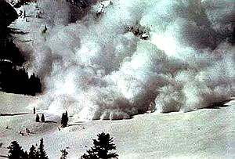
Buried by Multiple Avalanches
By: Jonathan Copp

THE FIRST AVALANCHE hit at midnight. The walls of our two ultralight tents collapsed, and we awoke to ice and snow squeezing us in the darkness.
It was late September, and we were deep in the Kumaun region of the Indian Himalayas to climb 22,510-foot Nanda Kot. I was with American mountaineers Chuck Bird, 41, Sarah Thompson, 28, and Pete Takeda, 43.
During our first attempt on the peak, we were hit by a severe north-blowing storm that, we would later learn, killed more than a dozen people.
Temperatures dropped to below zero, and heavy clouds dumped more than six inches of snow per hour. We'd taken shelter by chiseling our tents inside a crevasse that sloped downward into a seemingly bottomless pit. The orientation of the opening protected us from the full force of the avalanche, but the snow still poured in fast and deep.
As the cementlike mass pushed us farther into the crevasse, I fought to keep an air space in front of my mouth while tearing through the tent and pulling up frantically. When the slope finally settled, my head and one arm were above the surface. I started digging and found Sarah trapped near my knees. I burrowed until her hand grabbed mine. Pete heard the avalanche before it hit and grabbed an anchor we had set in the crevasse wall. He caught Chuck's arm just as their tent was crushed. Miraculously, everyone survived.
I found a headlamp, and we began digging for our boots in the ten feet of debris. There would be no way down the mountain without them. After six hours, we had dislodged everyone's boots, our ice tools, a stove, and four canisters of fuel. As the sun was rising, we cooked some dehydrated noodle soup, and we were sitting on our shredded tents when a second avalanche hit. I jumped up to standing and braced. It was 6:30 a.m., but suddenly it was dark again.
One headlamp popped on, then another. We were trapped in a 10-by-20-foot space. Pete and I dug a 15-foot long tunnel through the wall and poked our heads out into a raging storm. There was no way we could have survived out there. We decided to stay in the chamber until either we ran out of fuel or the storm surrendered. But this was just the lesser of two evils. The crevasse's unstable wall looked like it might collapse under the weight of the avalanche debris and new snow. And we were unroped. A fall into the abyss below would be fatal.
On the second day, we came up with ways to distract ourselves—building chairs out of snow, playing 21 questions. But by the third day, we couldn't escape what was on our minds: We are going to die here. But the storm suddenly lifted on the fourth day, and the slopes began to stabilize. We tunneled out and spent the next 12 hours rappelling and downclimbing 6,000 feet.
Expert Analysis: The crevasse probably saved their lives. But this is a desperate choice, as a crevasse is a classic example of a terrain trap, something we are always taught to avoid in an avalanche context. —John Kelly, operations manager of the Canadian Avalanche Centre

Thursday, October 25, 2007

Mauled by a Cougar
By: Nell Hamm
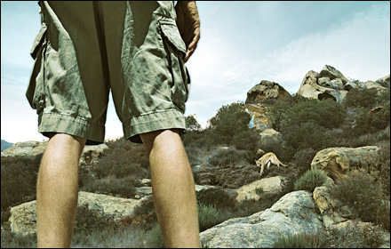
(Photo: Photo by Joe Baran)

As Told to Joe Spring
I HAD NEVER SEEN a mountain lion before, but I had always wanted to. I'd been told that if you saw one, you could just make noise and they would run; they don't want anything to do with you. But every now and then, you meet one that does.
I was walking ten feet ahead of my 71-year-old husband, Jim, taking in the beauty of Prairie Creek Redwoods State Park, on the Northern California coast, when I heard this horrible, horrible scream. Men don't scream like girls do. This was a call of terror. By the time I turned around, Jim was already on the ground, and the lion was on his back with his head in her mouth. The next thing I remember, I was holding a heavy, eight-foot-long redwood branch. I was afraid of hitting Jim in the head, so I swung at the cat's body. I'm 66, but I swim a mile three times a week, play tennis, and hike. I'm strong for an old lady. But I hit her with all I had and she didn't flinch. So I screamed and kept hitting her while yelling at Jim to fight. He reached up to poke the lion in the eye and twisted her nose. She didn't let go until he grabbed her tongue. Then she locked her jaw on his face and shook. Each time he fought, she fought back harder.
"There's a pen in my pocket," he said. "Get it and stick her in the eye." We were both so hopped up on adrenaline, I wasn't surprised that he could manage to speak. I just knelt down and pulled the plastic ballpoint out of his pocket. I thought it would go right into the soft part of the lion's eye and that would do it. But when I tried, the pen just buckled. She held on. My shoulders ached, but I picked up the log again and jammed the jagged point straight into the lion's snout. She let go and turned on me. She crouched down, ready to attack, snarling. Jim's blood was all over her face and chest. I waved the branch above my head and screamed, and she turned and walked off the trail, disappearing into the ferns.
Jim's arms and face were torn, his scalp was down to the bone, and he was bleeding profusely. I needed to get him out. I helped him to his feet and started yelling at him to walk, tears running down my face. He was weak but did a good job of moving. In a third of a mile, we reached the parkway. I lay Jim down on the road, with his head on a T-shirt. The cell phone didn't work. I grabbed two logs and waited by his side, in case the lion returned. A car came and I ran into the road and pointed at Jim, screaming. They swerved around and passed. Five minutes later another one came, and I jumped out in front of it. They went for help.
Jim spent three weeks in the hospital, enduring four surgeries and a life-threatening infection. He still has stiffness and pain in his right hand, but it hasn't stopped us from hitting the trails. We celebrated our 50th wedding anniversary a month after the attack. Still together, telling people never to hike alone.
Expert Analysis: I probably wouldn't hike in lion country without pepper spray or a knife. But the best thing they did was hike together. That fact saved the husband's life. And she did the right thing by yelling and making herself look larger. When you do that, mountain lions tend to want to get away. But they were also lucky. I helped with the necropsy on that lion, after she was captured. She was a juvenile, just 68 pounds. Females can reach 100 pounds. And they didn't know this, but there was a male lion in the area, too. If he had also attacked, it would've been different. —Jim Banks, wildlife pathologist with the California Department of Fish and Game

Survival Tip: Grizzly Attack
Run Away or Cower?
Don't run. Slowly back away, talk quietly, and don't make eye contact. If the bear attacks, drop facedown, spread your legs (making it harder to roll you over and maul your face), and protect the back of your neck. And next time bring pepper spray

Survival Tip: Backcountry Thunderstorm
Seek Shelter in a Shallow Cave or Scrunch Down? Shallow caves hold moisture and, like lone trees and exposed ridges, are lightning magnets. And lying down in a tent exposes you to electrical ground currents. Instead, crouch on your sleeping pad. If you're in a group, spread out so you can administer first aid quickly. If someone gets sizzled, they're not "electrically charged," so administer CPR immediately if they're not breathing. But let's rewind: Even before you set out, take a first-aid course from Wilderness Medicine Outfitters (wildernessmedicine.com).

Survival Tip: Thirst
Cut Open a Cactus or Collect Water from a Tree?
Don't waste energy cutting open a barrel cactus and trying to suck out the water. Cactuses are often heavy in alkaloids, which can induce vomiting, increasing dehydration. Instead, place a clear plastic bag over the branch of a desert willow and seal it securely. Water transpiring from the leaves can collect at the rate of a pint a day. (outdoorsafe.com).

Survival Tip: Avalanche
Swim Out or Create an Air Pocket?
Immediately after you get swept away, fight like hell to stay on the surface of the slide. But once you're engulfed, most experts now agree, "swimming" won't help you rise to the surface. Worse, after the snow slams to a stop, all that arm waving will have left you without an air pocket. The safer bet: Keep your hands near your face while you're tumbling. And, if possible, try to stick one hand above the surface. (Your chances of being found increase exponentially if a part of you is visible.) Better yet, take an avalanche-safety course (avalancheschool.org)

Survival Tip: Tornado
Hide Under a Highway Overpass or Jump into a Ditch?
Overpasses are overrated: Extreme winds funneled under them can dwarf the ambient winds of a tornado. If the tornado is still far off, your best bet is to drive away from its path at a right angle. If it's too close to escape, find a low area without water and lie down with your hands over the back of your head. Do not get in a car, which presents more wind resistance and can be tossed like a Matchbox toy. Only after the winds dissipate is it safe to get up. (ambientweather.com).

Survival Tip: Lost in the Wilderness
Follow a Stream or Stay Put?
Contrary to a popularly held belief, streams don't always lead to civilization. They often become waterfalls, are choked with vegetation, or present the risk of falling through ice. As a general rule, if you have shelter and will be reported missing, stay put. Clear off your car or wear your brightest gear for high visibility. To be extra safe, buy a 406 MHz emergency distress beacon like ACR's ResQFix (acrelectronics.com).

